**Assignment Topics**

**Question-1 (12 marks)**

1. Design a simple responsive web application using **Bootstrap 4** that includes the following elements:

* A **header** section with the title of the application.
* A **button group** with three Bootstrap-styled buttons (e*.g.,* Primary*,* Success*,* Danger), each triggering a different action when clicked (e.g., showing alerts or toggling content).
* Use **Bootstrap grid system** to create a layout that displays three cards side-by-side on larger screens and stacks them vertically on smaller screens.
* Apply a **Bootstrap theme** or utility classes to enhance the visual appeal (colors, spacing, typography).

1. Using **Bootstrap 4** and **jQuery**, design a simple interactive web page that includes the following features:
2. Create a form with the following fields:
   * Name (input)
   * Email (input)
   * Message (textarea)
   * A **Submit** button styled using Bootstrap classes
3. Use **jQuery selectors** to:
   * Access and validate the form fields when the **Submit** button is clicked.
   * Display an alert with the entered values if all fields are filled.
4. Handle a **click event** on the Submit button using jQuery and prevent the default form submission behavior.
5. Use a **Bootstrap modal** to display a confirmation message when the form is successfully submitted

<!DOCTYPE html>

<html lang="en">

<head>

<meta charset="UTF-8">

<meta name="viewport" content="width=device-width, initial-scale=1.0">

<title>Wanderlust Travel</title>

<!-- Bootstrap 4 CSS -->

<link rel="stylesheet" href="https://stackpath.bootstrapcdn.com/bootstrap/4.5.2/css/bootstrap.min.css">

<style>

body {

background-color: #f8f9fa;

}

.header {

background: linear-gradient(rgba(0,0,0,0.5), rgba(0,0,0,0.5)),

background-position: center;

color: black;

padding: 2rem;

text-align: center;

margin-bottom: 2rem;

}

.card {

transition: transform 0.3s;

}

.card:hover {

transform: translateY(-5px);

}

</style>

</head>

<body>

<!-- Header Section -->

<header class="header">

<h1 class="display-4">Wanderlust Travel</h1>

</header>

<!-- Main Content -->

<div class="container">

<!-- Button Group -->

<div class="mb-4 text-center">

<div class="btn-group" role="group" aria-label="Travel Actions">

<button type="button" class="btn btn-primary mr-2" onclick="showAlert('explore')">Explore Destinations</button>

<button type="button" class="btn btn-success mr-2" onclick="showAlert('book')">Book a Trip</button>

<button type="button" class="btn btn-danger" onclick="showAlert('contact')">Contact Us</button>

</div>

</div>

<!-- Card Grid -->

<div class="row">

<div class="col-lg-4 col-md-6 mb-4">

<div class="card h-100 shadow-sm">

<img src="https://images.unsplash.com/photo-1476514525535-07fb3b4ae5f1" class="card-img-top" alt="Paris">

<div class="card-body">

<h5 class="card-title">Paris, France</h5>

<p class="card-text">Experience the city of love with its iconic landmarks and romantic atmosphere.</p>

</div>

</div>

</div>

<div class="col-lg-4 col-md-6 mb-4">

<div class="card h-100 shadow-sm">

<img src="https://images.unsplash.com/photo-1502602898657-3e91760cbb34" class="card-img-top" alt="Tokyo">

<div class="card-body">

<h5 class="card-title">Tokyo, Japan</h5>

<p class="card-text">Discover the blend of traditional and modern in this vibrant metropolis.</p>

</div>

</div>

</div>

<div class="col-lg-4 col-md-6 mb-4">

<div class="card h-100 shadow-sm">

<img src="https://images.unsplash.com/photo-1496442226666-8d4d0e62e6e9" class="card-img-top" alt="New York">

<div class="card-body">

<h5 class="card-title">New York, USA</h5>

<p class="card-text">Explore the city that never sleeps with its diverse culture and attractions.</p>

</div>

</div>

</div>

</div>

</div>

<!-- Bootstrap 4 JS and dependencies -->

<script src="https://code.jquery.com/jquery-3.5.1.slim.min.js"></script>

<script src="https://cdn.jsdelivr.net/npm/popper.js@1.16.1/dist/umd/popper.min.js"></script>

<script src="https://stackpath.bootstrapcdn.com/bootstrap/4.5.2/js/bootstrap.min.js"></script>

<script>

function showAlert(type) {

let message;

switch(type) {

case 'explore':

message = 'Explore our curated list of destinations!';

break;

case 'book':

message = 'Ready to book your next adventure?';

break;

case 'contact':

message = 'Need assistance? Contact our support team!';

break;

}

alert(message);

}

</script>

</body>

</html>

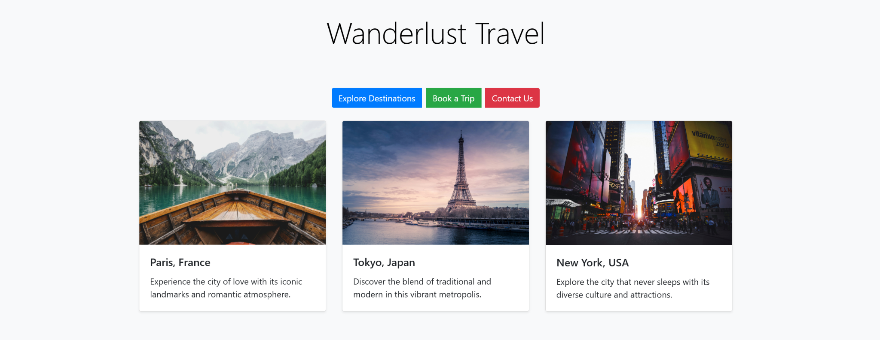

**Question -2 (28 marks)**

1. **A Form Component** with the following fields:
   * Name (text input)
   * Email (text input)
   * Description (textarea)
   * A **Submit** button
2. When the form is submitted:
   * The entered data should be displayed as a **Card Component** below the form using **React Bootstrap cards** or custom-styled cards.
   * Use **React state (useState or this.state)** to store and manage the form input and submitted data.
   * Each submitted form should generate a **new card** with the user's input.
3. Use basic styling to make the layout visually appealing (spacing, shadows, padding).

**In addition, your app should include:**

1. **Header Component** – Display a title using props (e.g.Photo Gallery App).
2. **Image Carousel Component**:
   * Use a library like **React Bootstrap Carousel** or create a custom one.
   * Load at least **3 images** into the carousel.
   * Allow navigation through **Next** and **Previous** buttons (use state to track current image index).
   * Images can be local or from URLs.
3. **Image Card Component**:
   * Display individual images using props (image source, title, and description).
   * A button labeled **"View Full Image"** should open the image in a new tab.
   * Use state to track how many times the image was viewed (i.e., button clicked).
4. **Main Page Layout**:
   * At the top: Header
   * Below: Carousel
   * Then: A row of 3 Image Cards (use the same component with different props)

<!DOCTYPE html>

<html lang="en">

<head>

<meta charset="UTF-8">

<meta name="viewport" content="width=device-width, initial-scale=1.0">

<title>Travel Contact Form</title>

<!-- Bootstrap 4 CSS -->

<link rel="stylesheet" href="https://stackpath.bootstrapcdn.com/bootstrap/4.5.2/css/bootstrap.min.css">

<style>

body {

background-color: #f8f9fa;

font-family: 'Arial', sans-serif;

}

.header {

background: linear-gradient(rgba(0,0,0,0.5), rgba(0,0,0,0.5)));

background-size: cover;

background-position: center;

color: black;

padding: 3rem;

text-align: center;

}

.form-container {

background-color: #fff;

border-radius: 10px;

padding: 2rem;

box-shadow: 0 4px 8px rgba(0,0,0,0.1);

margin-top: 2rem;

}

.btn-travel {

background-color: #007bff;

border-color: #007bff;

color: #fff;

}

.btn-travel:hover {

background-color: #0056b3;

border-color: #0056b3;

}

.form-control:focus {

border-color: #007bff;

box-shadow: 0 0 5px rgba(0,123,255,0.5);

}

</style>

</head>

<body>

<!-- Header Section -->

<header class="header">

<h1 class="display-4">Contact Wanderlust Travel</h1>

<p class="lead">Get in touch with us for your travel inquiries!</p>

</header>

<!-- Form Section -->

<div class="container form-container">

<form id="contactForm">

<div class="form-group">

<label for="name">Name</label>

<input type="text" class="form-control" id="name" placeholder="Enter your name">

</div>

<div class="form-group">

<label for="email">Email</label>

<input type="email" class="form-control" id="email" placeholder="Enter your email">

</div>

<div class="form-group">

<label for="message">Message</label>

<textarea class="form-control" id="message" rows="5" placeholder="Your message or inquiry"></textarea>

</div>

<button type="submit" class="btn btn-travel btn-block">Submit</button>

</form>

</div>

<!-- Modal -->

<div class="modal fade" id="confirmationModal" tabindex="-1" role="dialog" aria-labelledby="modalTitle" aria-hidden="true">

<div class="modal-dialog modal-dialog-centered" role="document">

<div class="modal-content">

<div class="modal-header">

<h5 class="modal-title" id="modalTitle">Thank You!</h5>

<button type="button" class="close" data-dismiss="modal" aria-label="Close">

<span aria-hidden="true">&times;</span>

</button>

</div>

<div class="modal-body">

<p>Your message has been received! We'll get back to you soon with travel tips and information.</p>

<p><strong>Name:</strong> <span id="modalName"></span></p>

<p><strong>Email:</strong> <span id="modalEmail"></span></p>

<p><strong>Message:</strong> <span id="modalMessage"></span></p>

</div>

<div class="modal-footer">

<button type="button" class="btn btn-travel" data-dismiss="modal">Close</button>

</div>

</div>

</div>

</div>

<!-- Scripts -->

<script src="https://code.jquery.com/jquery-3.5.1.min.js"></script>

<script src="https://cdn.jsdelivr.net/npm/popper.js@1.16.1/dist/umd/popper.min.js"></script>

<script src="https://stackpath.bootstrapcdn.com/bootstrap/4.5.2/js/bootstrap.min.js"></script>

<script>

$(document).ready(function() {

// Handle form submission

$('#contactForm').on('submit', function(event) {

event.preventDefault(); // Prevent default form submission

// Get form values

let name = $('#name').val().trim();

let email = $('#email').val().trim();

let message = $('#message').val().trim();

// Validate form fields

if (name === '' || email === '' || message === '') {

alert('Please fill in all fields.');

return;

}

// Validate email format

let emailRegex = /^[^\s@]+@[^\s@]+\.[^\s@]+$/;

if (!emailRegex.test(email)) {

alert('Please enter a valid email address.');

return;

}

// Populate modal with form data

$('#modalName').text(name);

$('#modalEmail').text(email);

$('#modalMessage').text(message);

// Show confirmation modal

$('#confirmationModal').modal('show');

// Clear form

$('#contactForm')[0].reset();

});

});

</script>

</body>

</html>

